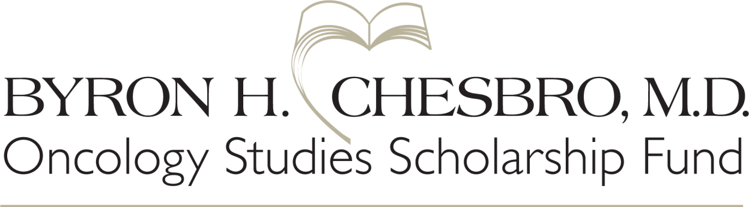

Applicant Information
Name
Address
City State Zip Code
Cell phone Email

Academic Professional Standing
(student applicants only)

College/University City State
Major GPA
Graduate Post/Graduate Study Program
Continuing Education Support
Program Date

Narrative Information
To give the scholarship committee a picture of your abilities in and commitment to the oncology field, please address each of the criteria below, using no more than 250 words each.
- Leadership
Describe leadership roles you have held and how those activities have helped to prepare you for your current career path.

- Advocacy
Provide an example of when you demonstrated advocacy in leading change or influencing an important cause, proposal or issue. If applicable, include an overview of that advocacy, your role, the outcomes and barriers to success and lessons learned.

- Inspiration and goals
What inspires you to pursue or continue an oncological health care career? Briefly describe your short and long-term goals for your career.

- Work/volunteer experience
Describe your work and/or volunteer experience and how these experiences have influenced your oncological pursuits and/or career.

- Please explain how you intend to use these funds.

- Include anything else you may wish the committee to know about you.

